# Ideation Phase

|  |  |
| --- | --- |
| Team ID | PNT2022TMID38362 |
| Project Name | Early Detection Of Chronic Kidney Disease  Using Machine Learning |

# Brainstroming & Idea Prioritization:

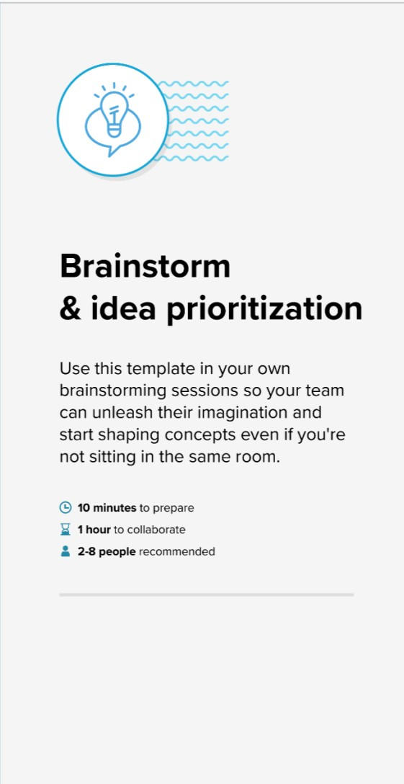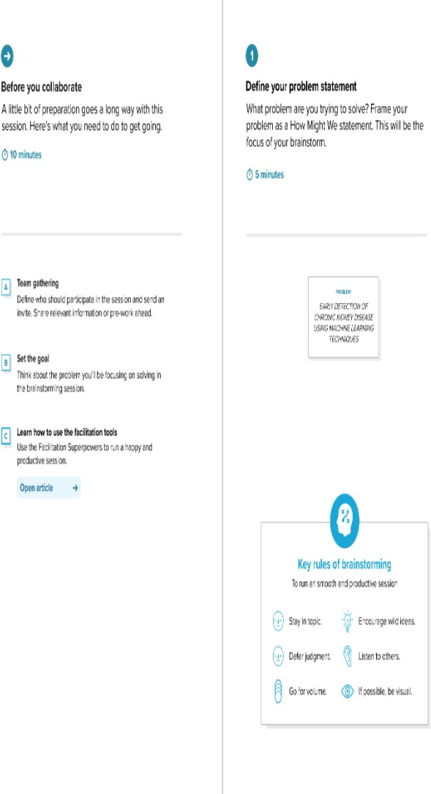Step-1: Team Gathering, Collaboration and Select the Problem Statement

Step-2: Brainstorm, Idea Listing and Grouping

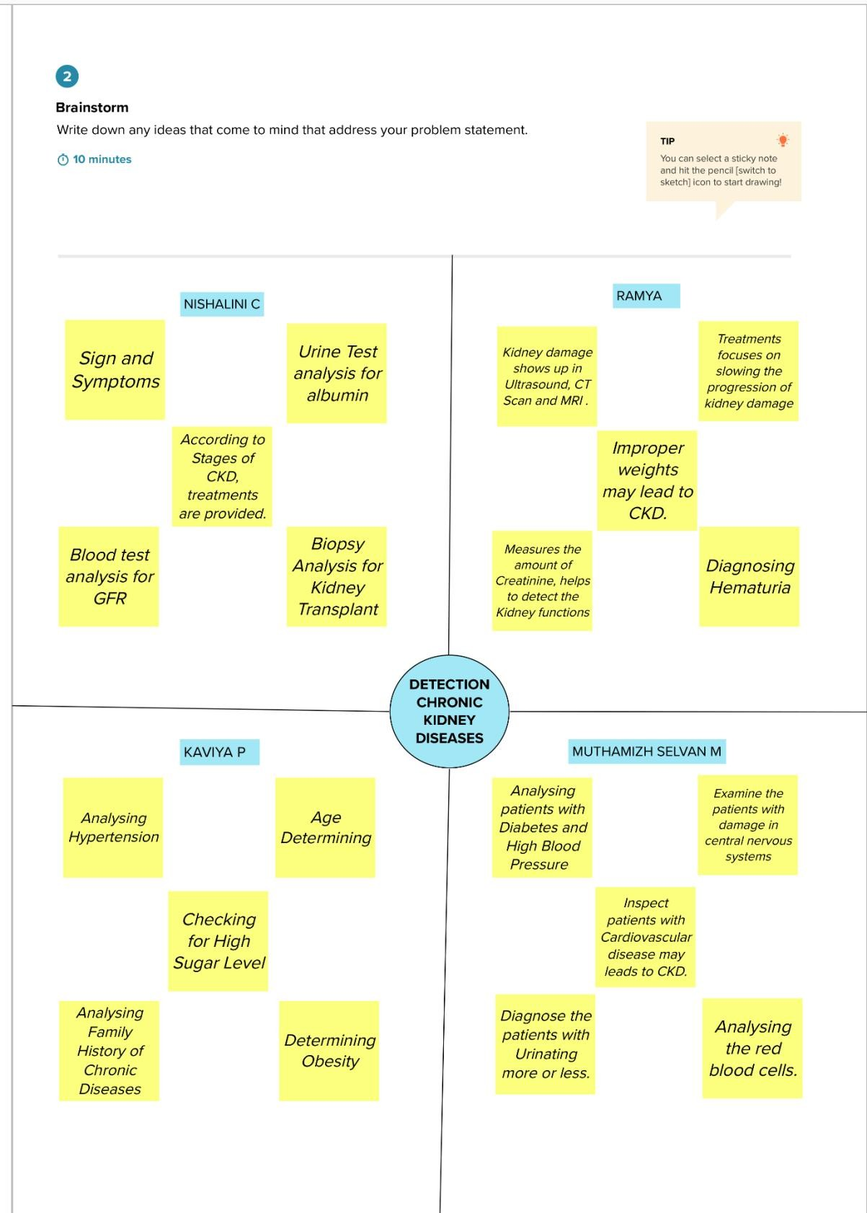

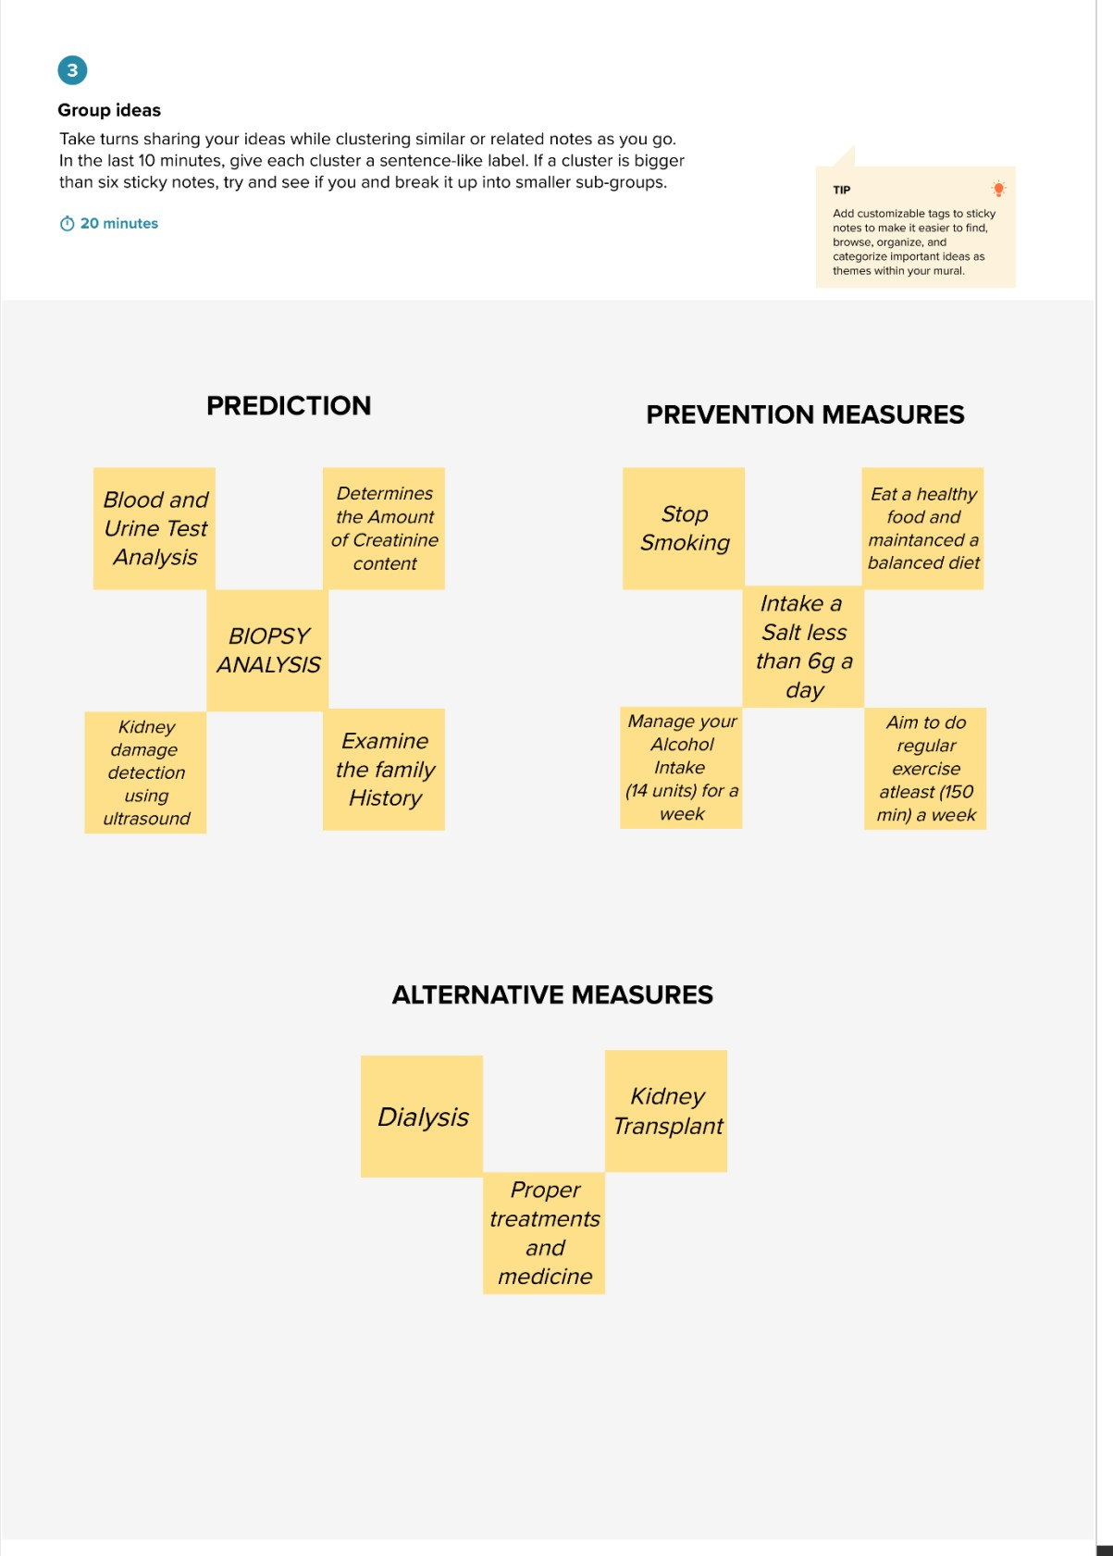

Step-3: Idea Prioritization

